DISTINCT TUMOR GENOMIC SIGNATURES

UNDERLIE CANINE MACROPHAGE POLARIZATION

Rachel V. Brady*1,2, Sunetra Das1, Dawn L. Duval1, Kristen B. Farrell1, Eric P. Palmer1,3, Douglas H. Thamm1

**Affiliations: 1**Flint Animal Cancer Center, Colorado State University, Fort Collins, CO, USA; 2Cell and Molecular Biology Graduate Program, Colorado State University, Fort Collins, CO, USA; 3 Department of Microbiology, Immunology, & Pathology, Colorado State University, Fort Collins, CO, USA.

*Corresponding author: Email [rbrady@ucdavis.edu](mailto:rbrady@ucdavis.edu); ORCID ID 0000-0002-5688-3872.

Please note that the current affiliation of Rachel V. Brady is Department of Surgical and Radiological Sciences, School of Veterinary Medicine, University of California Davis, Davis, California, USA.

**Funding Statement**: This work was supported by the National Institutes of Health Ruth L. Kirschstein Institutional National Research Service Award (NRSA) Training Grant T32OD01043, awarded through Colorado State University, and a gift from The Anschutz Foundation.

**Conflict of Interest Declaration:** The authors declare no potential conflicts of interest.

**Author Contributions:** All authors contributed to the study conception and design. Material preparation, data collection and analysis were performed by Rachel V. Brady, Sunetra Das and Eric P. Palmer. The first draft of the manuscript was written by Rachel V. Brady and all authors commented on previous versions of the manuscript. All authors read and approved the final manuscript.

**Data Access Statement:** The datasets used and analyzed during the current study are available from the corresponding author on reasonable request.

**Acknowledgements:** The authors thank Rupa Idate for extensive work in maintaining and validating cell lines, and Laurel Haines for generously sharing her expertise on exosome biology.

**ABSTRACT**

There is poorly understood variability between and within cancer types in their ability to maintain an immunosuppressive microenvironment and polarize tumor-associated macrophages (TAMs). Identifying genetic biomarkers of cancers that strongly polarize TAMs could enable discovery of novel therapeutic targets and support stratification of patients for appropriate immunotherapy. Our aim, therefore, was to correlate gene expression data from cancer cell lines with phenotypic changes in canine macrophages. We harvested standardized tumor conditioned medium (TCM) from twenty-five canine cancer cell lines with RNA-sequencing data available. Primary monocyte-derived macrophages were obtained from three canine donors and polarized with the TCM. After a washout period, supernatants were collected, and polarization changes of the macrophages were assessed via secretory products. For each analyte, a modified z-score was used to rank each cell line’s ability to stimulate cytokine secretion from macrophages. Spearman's correlation and pairwise analysis was performed. Many significantly differentially expressed genes were identified in the cancer cell lines having the strongest ability to polarize macrophages. Cell lines with MVB12A upregulated, a gene involved in selecting cargo for exosomes, had the highest ability to stimulate VEGF production from macrophages. Other genes involved in macrophage immunosuppression were upregulated, and in cell adhesion and metastasis-prevention were downregulated. In conclusion, canine cancer cell lines have varying abilities to polarize macrophages irrespective of histologic type as measured by secretory products. The cell lines capable of potent polarization had relevant differentially expressed genes and pathways. These are currently being explored to identify novel biomarkers and therapeutic targets.

*Keywords: Tumor microenvironment, tumor-associated macrophages, biomarkers, tumor-conditioned media, polarization.*

**INTRODUCTION**

The tumor microenvironment (TME) drives cancer progression via tumor growth, metastasis, and treatment resistance [1]. Many new cancer therapies are TME-centric rather than cancer cell-centric, highlighting the importance of the TME [2]. There is major variability in the TME, both between and within tumor types [3]. Single-cell sequencing has identified immune cell compositions within the TME that are common across cancer types and multiple TME subtypes within a single tumor type [4]. This variability contributes to the mixed success of immunotherapies and makes patient stratification challenging [5].

The TME is shaped by many factors, only some of which are well-understood. Tumor histopathology determines a broad range of pathological patterns. Metastatic melanoma and non-small cell lung cancer (NSCLC) are commonly treated with immune checkpoint inhibitors. However, many patients fail to achieve sustained benefits from these therapies, partly because of the heterogeneity of the TME [6, 7]. Mutations in cancer-related genes affect the TME. Loss of *PTEN* is associated with T-cell exclusion and immunotherapy resistance [8]. Similarly, gain-of-function p53 has immunosuppressive and pro-metastatic effects [9]. Patient factors, such as weight and age, influence the TME via changes in cellular metabolism and inflammation [10, 11]. TME metabolic variability changes glucose, amino acid, and lipid availability, affecting crosstalk between immune and cancer cells [12]. Epigenetic regulation of the TME can also lead to a “cold” TME, lacking in cytotoxic T-cell infiltration [13]. Cancer therapy applies pressure on the TME, resulting in evolution over time [1]. Together, these factors make the TME a formidable barrier to effective immunotherapy.

Tumor-associated macrophages (TAMs) are the most abundant immune cells in the TME and comprise a heterogeneous group with diverse phenotypes [4]. They are being investigated as therapeutic targets and biomarkers in cancer. TAMs are usually described as having an “M2-like” or immunosuppressive phenotype, although the dichotomous M1/M2 categorization is overly simplistic. Still, most TAM phenotypes promote tumor progression. They drive angiogenesis, facilitate tumor cell invasion and metastasis, and enhance immune evasion [14]. Many TAM-targeted therapies are in early-stage clinical trials in humans, and some have been explored in canine cancer [15].

Canine cancer offers a translational bridge between preclinical models and clinical trials. Dogs have become a frequently used model for studying human cancer because of the similarities in their spontaneously occurring tumors, biology, immune systems, and environmental exposure [16]. Incorporating canine clinical trials into the preclinical drug discovery pathway has many advantages. Several FDA-approved cancer drugs have been discovered and approved through the parallel efforts of human and veterinary researchers [17].

Despite major advances in immunotherapies, few biomarkers can accurately predict response [18]. Therefore, there is a need for better TME-based biomarkers. In this study, we introduce a novel method for TME biomarker discovery. We aimed to correlate canine macrophage phenotypes after polarization with tumor-conditioned media (TCM) with transcriptomic data from canine cancer cell lines. We hypothesized that canine cancer cell lines would have varying abilities to polarize primary macrophages irrespective of their tumor of origin. We also hypothesized that the strong polarizers macrophages would have relevant differentially expressed genes (DEGs), possibly useful as biomarkers or therapeutic targets.

**MATERIALS AND METHODS**

*Cell line maintenance and validation*

Cell lines were cultured in DMEM or RPMI (Gibco, Grand Island, NY) supplemented with MEM vitamins (Corning), 2 mM L-glutamine, 1 mM sodium pyruvate, and 10–20% FBS (Peak Serum, Bradenton, FL) (D10/R10/R20). Cultures were maintained at 37 °C with 5% CO₂ and routinely passaged. All lines were confirmed canine, mycoplasma-free, with RRIDs listed in **Supplementary Table 1** [19].

*Generation of standardized TCM*

Adherent cells were thawed, seeded into T-150 flasks with D10, grown to ~80% confluence (≥24 h), trypsinized, and 1×10^6 cells re-seeded. At ~80% confluence, media was replaced with 9 mL D10. After 24 h, TCM was collected, spun, and stored, and cells were counted. Suspension cells were seeded into T-150 flasks with R10, grown 48 h, counted, and 1×10^6 cells re-seeded. After 2–4 days, cultures were counted, then 60% of the median adherent cell number was seeded into T-150 with 9 mL D10. After 24 h, TCM was collected and cells counted.

*Primary macrophage culture*

Canine peripheral blood mononuclear cells (PBMCs) were isolated by density-gradient centrifugation under an approved protocol and plated in R20 for overnight monocyte adherence. Monocytes were differentiated for 7 days in R20 with 40 ng/µL monocyte colony-stimulating factor (M-CSF). Macrophages from three donors were polarized for 24 h with 70% TCM/30% R10 or control medium (70% D10/30% R10), washed three times with PBS, incubated in R10 for 24 h, and supernatants collected. Cell-free wells confirmed TCM removal. Donor information is in **Supplementary Table 2**, and further details in **Supplementary Methods**.

*Cytokine analysis of cell supernatants*

Concentrations of c–c motif chemokine ligand 2 (CCL2), vascular endothelial growth factor (VEGF), transforming growth factor-beta (TGF-β), tumor necrosis factor-alpha (TNF-α), and CCL3 were measured using individual enzyme-linked immunosorbent assay (ELISA) kits. In parallel, an immunology multiplex assay (MILLIPLEX® canine cytokine/chemokine panel) was performed on a Luminex MagPix with xPONENT® software. Eight analytes were below quantification limits and excluded. CCL2 exceeded the assay range and required 150× dilution for ELISA. Product details are provided in **Supplementary Methods.**

*Normalization of results*

Absolute values from ELISAs and the multiplex panel were normalized. Because the data were non-normally distributed, a modified z-score was calculated for each analyte as 0.6745 x (data point – dataset median) / median absolute deviation [20]. Modified z-scores were used to rank cancer cell lines, with higher values indicating greater macrophage stimulation and lower values indicating less. Scores were then correlated across analytes and with previously published mutational and phosphorylation data [21].

*RNA-sequencing and analysis*

Spearman’s rank correlations were computed between each gene’s expression (transcripts per million [TPM] and removed unwanted variation using control genes [RUVg]-normalized) and cytokine modified z-scores. Differential expression between “high” and “low” macrophage stimulators (top/bottom modified z-score quartiles) was analyzed in DESeq2 using the filtered raw count matrix (excluding genes with ≤3 counts or detected in <50% of samples). Genes with |log₂FC| ≥ 1 and Benjamini–Hochberg (BH)-adjusted p ≤ 0.05 were considered significant. Pre-ranked gene set enrichment analysis (GSEA) was run against Molecular Signatures Database (MsigDB) Hallmark (H), Curated (C2), Oncogenic (C6), and Immunologic (C7) gene sets, with BH-adjusted p ≤ 0.25 considered significant. CCL3 transcript counts were also extracted from public datasets (NCBI BioProject PRJDB11462, PRJEB36828, PRJDB17594). Additional details are provided in **Supplementary Methods.**

*Exosome depletion and validation study*

Seven top VEGF-stimulating cell lines were selected. Aliquots of their TCM were thawed and divided into whole TCM, exosome-depleted TCM (Amicon Ultra centrifugal filters; Millipore Sigma #UFC210024), and exosome-only fractions. Exosome concentrations were quantified by tunable resistive pulse sensing (qNano Gold, Izon; nanopore 150, ~47 nm stretch, calibrated with #NP100 and #CPC200 particles). Macrophages from three canine donors were differentiated for 7 days, treated with each condition (7 lines × 3 fractions), washed, and supernatants assayed for VEGF. For exosome-cargo analysis, exosome fractions were lysed in 5× RIPA buffer (volume matched to the exosome-depleted fraction) before VEGF measurement [22].

To replicate our findings, fresh TCM was generated from two high-VEGF lines (Nike, Parks), two low-VEGF lines (CLL1390, 1771), and four additional lines selected by *MVB12A* expression. Macrophages from three new donors were treated with these eight TCM, and VEGF in supernatants was measured by ELISA as above.

*CCL3 assays*

Macrophages from three new canine donors were stimulated in triplicate with recombinant canine CCL3 (Novus Biologicals, Centennial, CO, #NBP3-11065) across a concentration range for 24 h. Supernatants were assayed for TNF-α by ELISA and corrected for cell loss at higher CCL3 levels. DH82 cells underwent *CCL3* knockdown to generate fresh TCM from wild-type (WT), knockdown (KD), and non-targeting control (NTC) cells. Donor macrophages were treated with each TCM in triplicate for 24 h, washed, and supernatants assayed for CCL3 by ELISA. Detailed knockdown methods are provided in **Supplementary Methods.**

*Statistical Analysis*

Analyses and data visualization were performed using GraphPad Prism (RRID:SCR_002798) and R version 4.3.1 (RRID:SCR_001905) [23].Normality was assessed by the Shapiro–Wilk test, and data are reported as mean ± SEM or median (range). Two-group comparisons used unpaired two-tailed t-tests (with Welch’s correction if needed) or Wilcoxon rank-sum tests for non-normal data. For ≥3 groups, one-way ANOVA was applied when assumptions were met and Kruskal–Wallis otherwise. Overrepresentation analysis used 5,000 permutations with a fixed random seed and Benjamini–Hochberg (BH) adjustment. Intraclass correlation coefficients (ICCs) quantified inter-donor variability, and likelihood ratio tests assessed donor effects. Correlations were tested with Spearman’s rank, linear regression, or linear mixed-effect models (donor as random effect). For correlations with mutational or phosphorylation data, *p*-values were BH-adjusted using the false discovery rate (FDR); unadjusted values are reported for exploratory analyses. Significance was set at *p* < 0.05 unless otherwise specified.

**RESULTS**

*Classification and correlation of macrophage secretions*

Macrophage-secreted cytokines and chemokines were quantified in 25 canine cancer cell lines after TCM treatment. The mean cell count at TCM harvest was 11.04 × 10^6 (range 4.6–20.04 × 10^6), with no significant differences across tumor types (**Supplementary Figure 1**). Of 15 analytes measured, seven were consistently detectable: CCL2, IL-8, IL-10, KC-like, TNF-α, TGF-β, and VEGF. Significant inter-donor variability was observed for most cytokines. CCL2 and VEGF showed the greatest variability, consistent with wide dynamic ranges and high ICCs. KC-like (*p* = 0.055) showed a relatively high ICC, indicating more consistent responses across donors. Descriptive statistics, ICCs, and *p*-values are listed in **Table 1**. Modified z-scores are shown in **Figure 1** and raw donor values in **Supplementary Figure 2**.

**Table 1. Analytes included for further analysis.** Data are expressed as modified z-scores. A modified z-score of +1.0 indicates the measurement lies one median absolute deviation (MAD) above the median, of -1.0 indicates one MAD below. Interclass correlation coefficients (ICCs) represent the fraction of residual variance after accounting for treatment effect attributable to donor identity and the corresponding *p*-value from a likelihood-ratio test comparing models with and without donor as a random effect. Min = minimum, Max = maximum.

|  |  |  |  |  |  |  |
| --- | --- | --- | --- | --- | --- | --- |
| **Analyte** | **Median** | **Min** | **Max** | **Range** | **ICC** | ***p*-value** |
| **VEGF** | 0.8998 | -0.7566 | 3.4840 | 4.2410 | 0.614 | <0.001 |
| **TNF-α** | 0.4402 | -0.6415 | 16.020 | 16.660 | 0.182 | 0.002 |
| **IL-10** | 0.4153 | -0.5104 | 39.730 | 40.240 | 0.115 | 0.028 |
| **CCL2** | 0.1410 | -0.1905 | 0.7910 | 0.9815 | 0.754 | <0.001 |
| **IL-8** | 0.1068 | -0.7979 | 1.7820 | 2.5800 | 0.209 | <0.001 |
| **KC-like** | -0.0092 | -1.4630 | 2.4330 | 3.8950 | 0.096 | 0.055 |
| **TGF-β** | -0.0014 | -0.5611 | 1.194 | 1.755 | 0.628 | <0.001 |



**Figure 1: Modified z-scores of each analyte.** Mean modified z-score for each cytokine secreted by donor macrophages, ranked in descending order, color-coded by tumor type. Vertical dotted line represents the mean modified z-score of control macrophages from the same 3 donors. Data are mean +/- standard error of the mean (SEM); n=3.

Neither cell number at TCM harvest nor tumor type significantly affected analyte levels, indicating results were not driven by cell density or tumor origin (**Supplementary Table 3, Supplementary Figure 3**).

Two cytokine pairs were significantly correlated after adjustment, with the strongest association between IL-10 and TNF-α (**Figure 2**). Therefore, TCM that induced high IL-10 secretion also tended to induce high TNF-α. No cell lines or tumor types were significantly overrepresented in the top or bottom quartiles across analytes by permutation testing. Cell line 1771 (B-cell lymphoma) showed a trend toward overrepresentation in the bottom quartiles (adj. *p* = 0.064).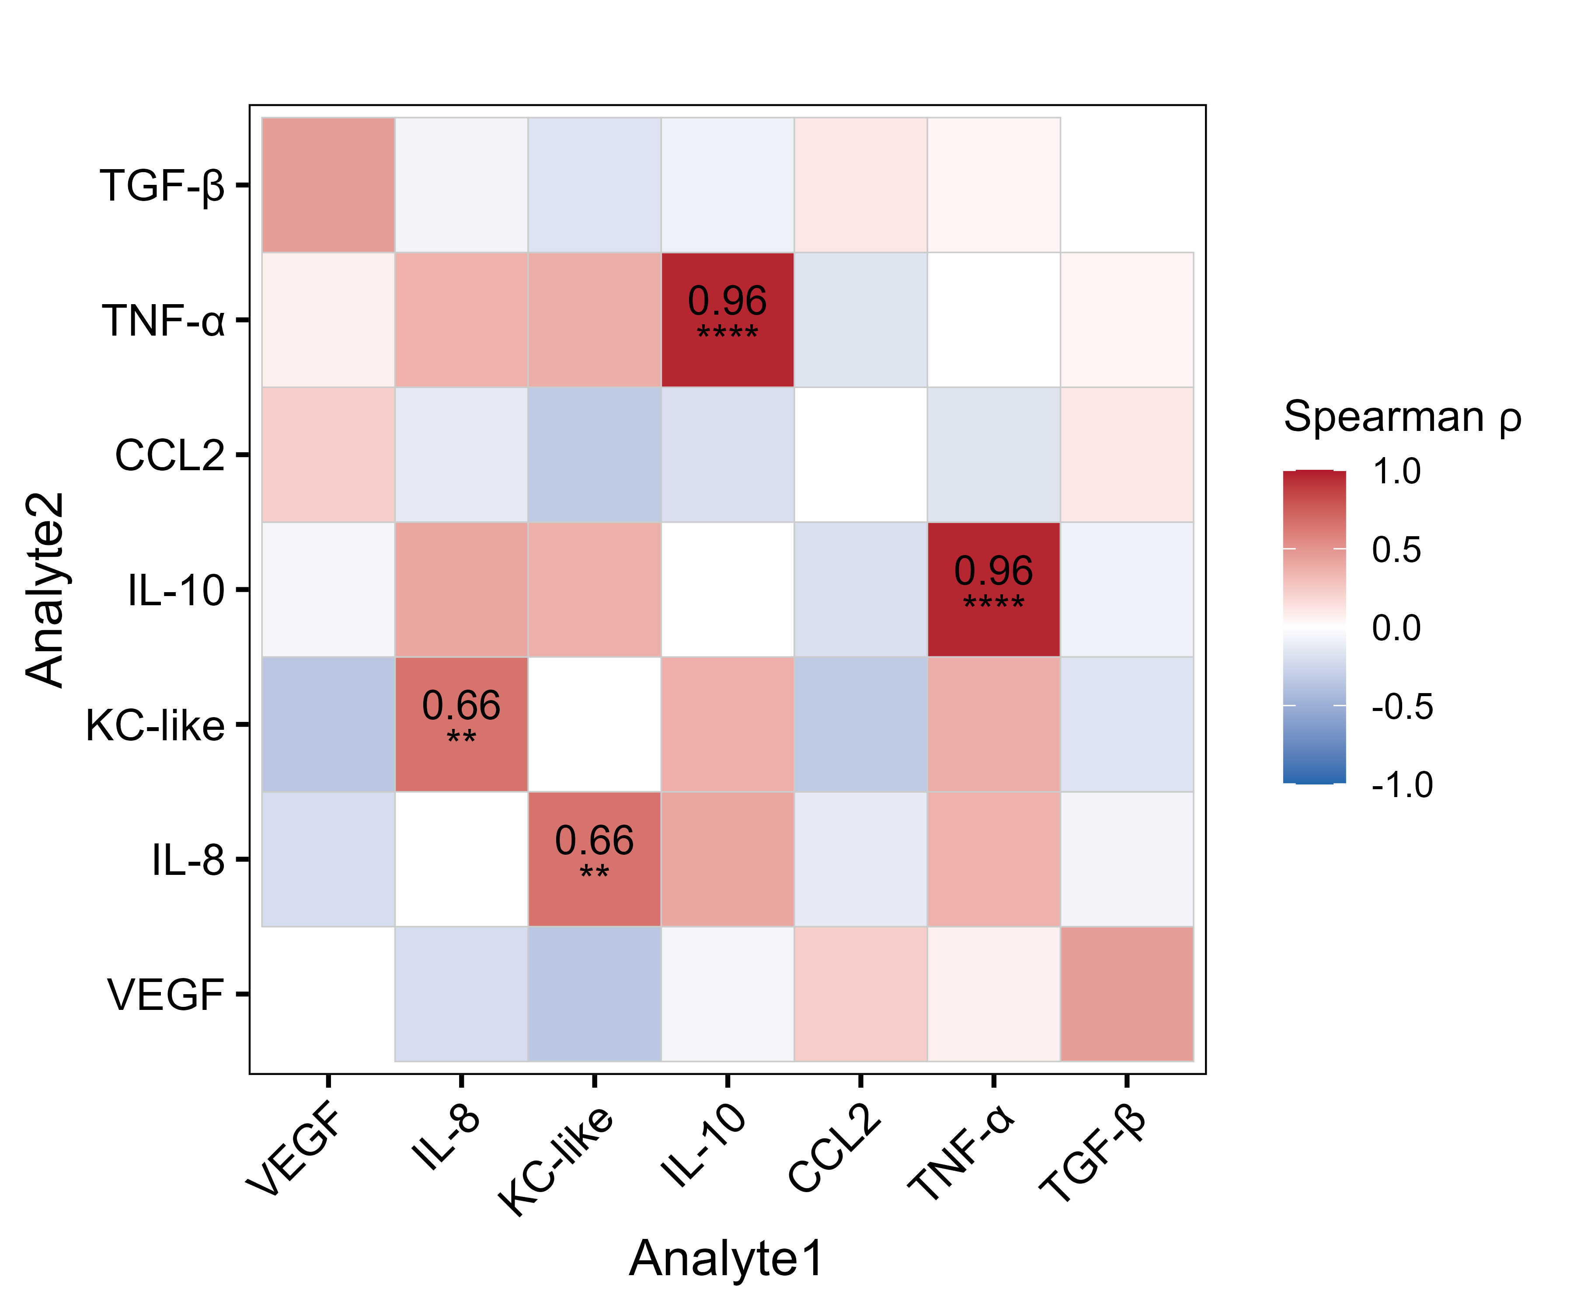

**Figure 2: Spearman correlation heatmap of cytokine secretion.** Each tile is colored by the Spearman ρ value (red = positive correlation, blue = negative correlation; scale bar at right). Statistically significant correlations false discovery rate correction for multiple comparisons are annotated: ** *p* < 0.01, **** *p* < 0.0001.

Whole-exome sequencing of >30 canine cell lines was previously performed at the FACC, categorizing mutational status and phosphorylation of protein kinase B (pAKT) and extracellular signal-regulated kinase (pERK) classified as active, constitutive, or low in 23 lines used here [21]. We next tested for correlations between these data and our results. None remained significant after FDR correction, but two trends were noted. TCM from cell lines with ≥2 driver mutations tended to stimulate higher TGF-β (adj. *p* = 0.075), and TCM from lines with active pAKT tended to stimulate higher CCL2 (adj. *p* = 0.068 vs. constitutive pAKT).

*Canine cancer cell lines capable of potent polarization have relevant DEGs and pathways*

Investigators at the FACC have previously performed RNA-seq on 23 of the 25 cell lines used in this study [24]. We correlated cytokine modified z-scores with RNA-seq data using Spearman’s rank analysis. For VEGF, two genes showed strong associations with modified z-scores. Multivesicular body subunit 12A (MVB12A; ρ = 0.817, q = 0.038) was upregulated in high VEGF-stimulating cell lines and encodes a core ESCRT-I subunit regulating exosome biogenesis [25]. An unannotated Ensembl ID (ENSCAFG00000024217; ρ = 0.813, q = 0.038) was identified by orthology as trafficking protein particle complex subunit 5 (TRAPPC5), part of the TRAPP complex involved in vesicular trafficking [26, 27]. These results suggest a mechanistic link between tumor cell vesicle/exosome pathways and macrophage VEGF release (**Figure 3**). Complete correlation results are in **Supplementary Table 4**.

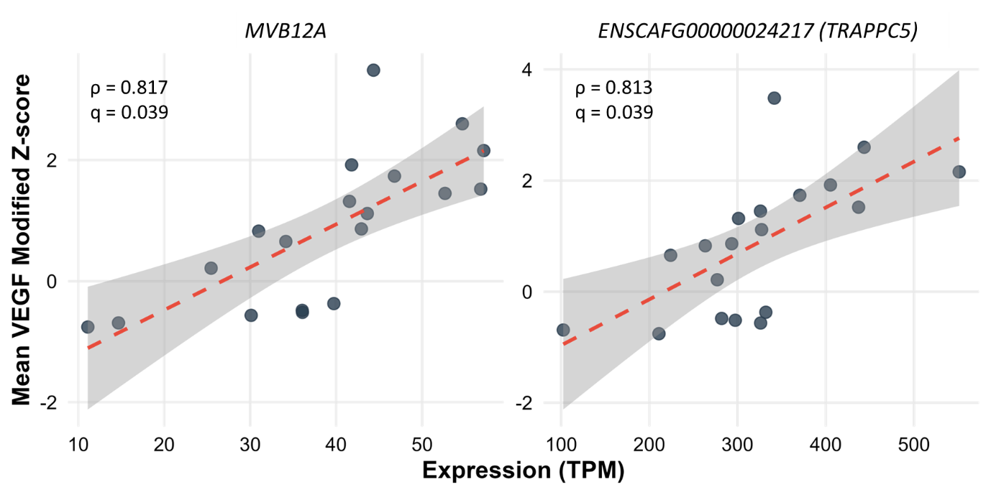

**Figure 3: Spearman’s correlation between gene expression and VEGF response.** Scatter‐plots showing the relationship between TPM‐normalized RNA-seq expression of *MVB12A* (left panel) and *TRAPPC5* (ENSCAFG00000024217; right panel) versus mean VEGF modified Z-scores. Dashed red lines depict the linear regression trend with 95% confidence bands shaded in grey; annotations show each gene’s Spearman ρ and q-value.

Pairwise differential gene analysis was performed by defining “high” and “low” stimulator groups for each analyte based on the top and bottom quartiles of modified z-scores. Significant differences were observed for all analytes (**Supplementary Table 5**). IL-8 and KC-like each had 3 DEGs, whereas other cytokines had 10–60 (**Figure 4**). Positive correlations indicate higher gene expression with greater macrophage secretion, while negative correlations indicate higher gene expression with lower macrophage secretion. In high-stimulator cell lines, upregulated DEGs included macrophage activation/recruitment (*CSF1R, CCL7, STAB1, ADAM8, CXCL14, IL12A*), epithelial-to-mesenchymal transformation (EMT) (*SNAI1, SEMA7A*), extracellular matrix remodeling (*COL6A3*), and metabolic reprogramming (*GFPT2, SMPDL3A*). Downregulated DEGs included immune surveillance markers (*LAPTM5, CTSS*) and cell adhesion genes (*SEPTIN1, ACTA2*). A full DEG list is provided in **Supplementary Table 6**.

We then performed GSEA with the gene lists from the pairwise analysis based on pre-ranked log2FC values using MsigDB’s hallmark, C2, C6, and C7 collections. The high-stimulator groups showed enrichment for EMT (CCL2, VEGF), immune suppression (CCL2, TGF-β, VEGF), MEK signaling (IL-8), macrophage response/activation (CCL2, IL-10, TNF-α), extracellular matrix remodeling (TNF-α, VEGF) and suppression of IL-2 signaling (TNF-α). A selection of relevant enriched gene sets is shown in **Figure 5**. All gene sets are provided in **Supplementary Table 7.**

*Cell lines with upregulated MVB12A had the strongest ability to stimulate VEGF from macrophages.*

We validated our RNA-seq correlation findings suggesting that *MVB12A* expression in cancer cell lines is associated with VEGF stimulation from primary macrophages. *MVB12A* encodes a subunit of ESCRT-I involved in exosomal cargo sorting, leading us to test whether exosomes mediate this response [25]. VEGF levels were first measured in TCM from 7 top VEGF-stimulating lines, but TCM VEGF production was not significantly correlated with macrophage VEGF induction (mixed-effects model, *p* = 0.397). As described in Methods, TCM was fractionated into whole, exosome-depleted, and exosome-only conditions. Macrophages treated with the exosome-only fraction secreted significantly more VEGF than those treated with whole or exosome-depleted TCM (mixed-effects model accounting

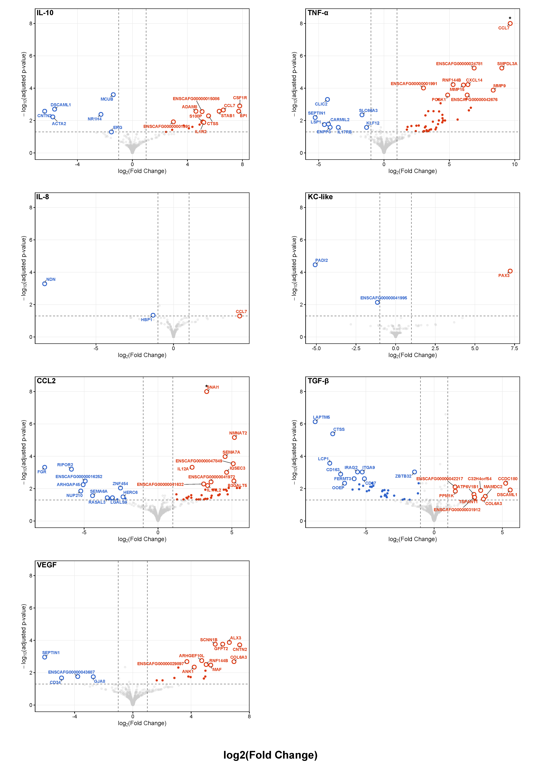

**Figure 4: Volcano plots of DEGs in pairwise analysis.** In each panel, the x-axis shows the shrunken log₂ fold-change and the y-axis shows –log₁₀ of the Benjamini–Hochberg–adjusted *p*-value. Dashed lines at ±1 log₂ fold change (FC) and FDR = 0.05 indicate the significance thresholds. Genes with |shrunken log₂FC| ≥ 1 and FDR ≤ 0.05 are colored red (up-regulated) or blue (down-regulated); all others are shown in gray. An asterisk marks a value that exceeds the plotted range. The top 10 most significant up- and down-regulated genes (ranked by adjusted *p*-value and effect size) are labeled.

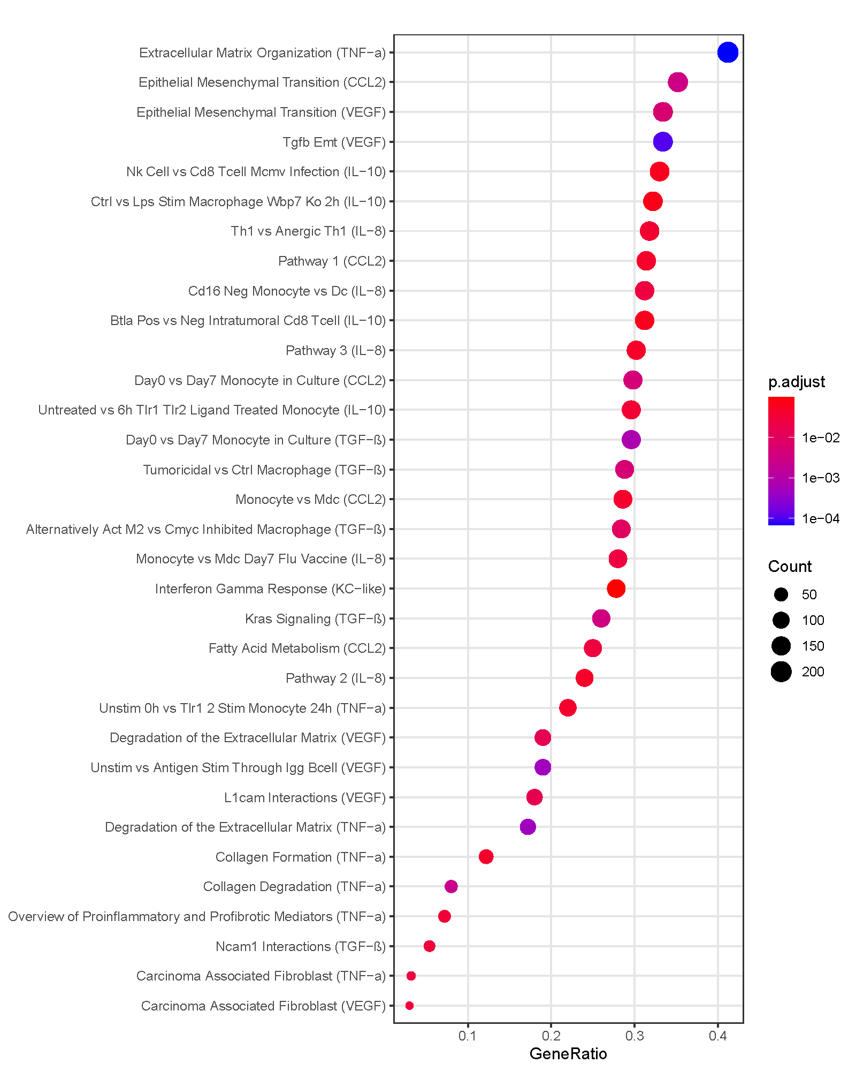

**Figure 5: Select enriched pathways across cytokines.** The plot shows enriched pathways (y-axis) ordered by gene ratio, with associated cytokines listed in parentheses. Dot color indicates adjusted *p*-value, and dot size is proportional to gene count. Pathway names have been edited for clarity.

for cell line and donor; **Figure 6A**). Analysis of each line individually with donor as a random effect showed that the exosome-only fraction stimulated higher VEGF than whole TCM in all lines except OS2.4.

To further validate this finding, we generated fresh TCM from eight cell lines: four from the original experiment (Parks, Nike, 1771, and CLL-1390) and four newly selected (CIN, SB, Angus, and Tyler) based on *MVB12A* expression. Seven of the eight lines stimulated macrophages as predicted, with high *MVB12A* associated with high VEGF. When all eight were analyzed, the difference in VEGF stimulation between high- and low-*MVB12A* groups was not significant (p = 0.13). CIN, a hemangiosarcoma (HSA) line, showed unexpectedly low VEGF stimulation despite high *MVB12A.* Excluding CIN as a potential outlier, the remaining lines showed a significant difference in VEGF stimulation on Welch’s t-test (*p* = 0.0098) (**Figures 6B and 6C**).

To test whether exosomes carried VEGF or stimulated VEGF indirectly, TCM aliquots from the eight lines were depleted of exosomes, producing exosome-depleted TCM and concentrated exosomes (resuspended to equal volume). Comparing VEGF in lysed exosome fractions and exosome-depleted fractions showed all *MVB12A*-high lines, including CIN, had higher VEGF in the lysed concentrated exosome fraction, consistent with exosome-associated cargo (**Figure 6D**).

Finally, in Parks and Angus (two high-*MVB12A* lines), VEGF was again compared between the concentrated exosome fraction and exosome-depleted TCM, but this time the exosomes were not lysed The VEGF ratio decreased (Parks: 17.7x to 5.8x; Angus: 7.0x to 1.3x), suggesting much of the VEGF is packaged inside exosomes rather than co-isolated with them. Further studies using more rigorous exosome-isolation methods are required to confirm these findings. No dose-response relationship was observed between the number of exosomes and VEGF stimulation in any of the experiments.



**Figure 6: Validation of *MVB12A*’s role in exosome-associated VEGF stimulation. (A)** VEGF secretion by macrophages after treatment with whole tumor-conditioned media (TCM), exosome-deplete TCM, and exosome-only media, n=3 donors (averaged) and 7 cell lines per condition. **(B)** VEGF secretion from macrophages incubated with TCM derived from high- versus low-*MVB12A* cell lines, n=3 donors. Significance bracket excludes CIN due to atypical behavior (*p* = 0.0089, Welch's t-test; see text). **(C)** RUVg-normalized counts of *MVB12A* expression across all cell lines. For (B) and (C), colors indicate high (purple) and low (blue) expressors; darker shades denote the discovery set, lighter shades the validation set. **(D)** Ratio of presumed exosome-associated to free VEGF in the 7 high- vs. low-*MVB12A* lines from (B) and (C) (*p* = 0.032, Student’s t-test). Data shown are mean +/- standard error of the mean (SEM).

*Cell lines with CCL3 upregulated stimulated high levels of TNF-α from macrophages.*

Preliminary inspection of pairwise analysis on unfiltered RNA-seq data showed that only two histiocytic sarcoma (HS) cell lines (DH82 and Nike) expressed high levels of *CCL3*, which was positively associated with TNF-α secretion from macrophages (adj. *p* = 5.93E-14, log2FC = 24.92). *CCL3*, also known as macrophage inflammatory protein 1α, recruits myeloid cells and facilitates T-cell responses in the TME [28]. These data were filtered out of the final pairwise analysis, but because both lines originated from the same tumor type, we further investigated CCL3 involvement in macrophage TNF-α stimulation as a mechanism potentially unique to HS. Publicly available RNA-seq datasets and shared unpublished FACC data showed that CCL3 is broadly expressed in canine HS tumors and cell lines (S. Beeson and D. Duval). Analysis of an expanded FACC panel of 42 cell lines across tumor types, including those used here, revealed measurable CCL3 transcripts in only four lines: the two HS lines (DH82, Nike) and two hematopoietic tumors (BRMCT, mast cell tumor; CLBL1, B-cell lymphoma) (S. Das and D. Duval, personal communication). These findings suggest that CCL3 expression is common in canine HS and may be unique to hematopoietic tumors.

We first measured CCL3 levels in all TCM. As expected, DH82 and Nike secreted the highest amounts of CCL3, while several other lines had low concentrations not captured at the transcript level in RNA-seq (**Figure 7A**). We replicated these findings with recombinant canine CCL3, which induced a dose-dependent increase in TNF-α secretion from macrophages. Results were adjusted for relative cell counts, as more macrophages were detached at higher CCL3 concentrations (**Figure 7B**). *CCL3* knockdown was confirmed at ~50% efficiency in KD-DH82 cells (**Supplementary Figure 4**). In two donors, macrophages treated with TCM from KD-DH82 cells showed on average a 45% decrease in TNF-α secretion compared to NTC-DH82 TCM, although one donor showed increased TNF-α.

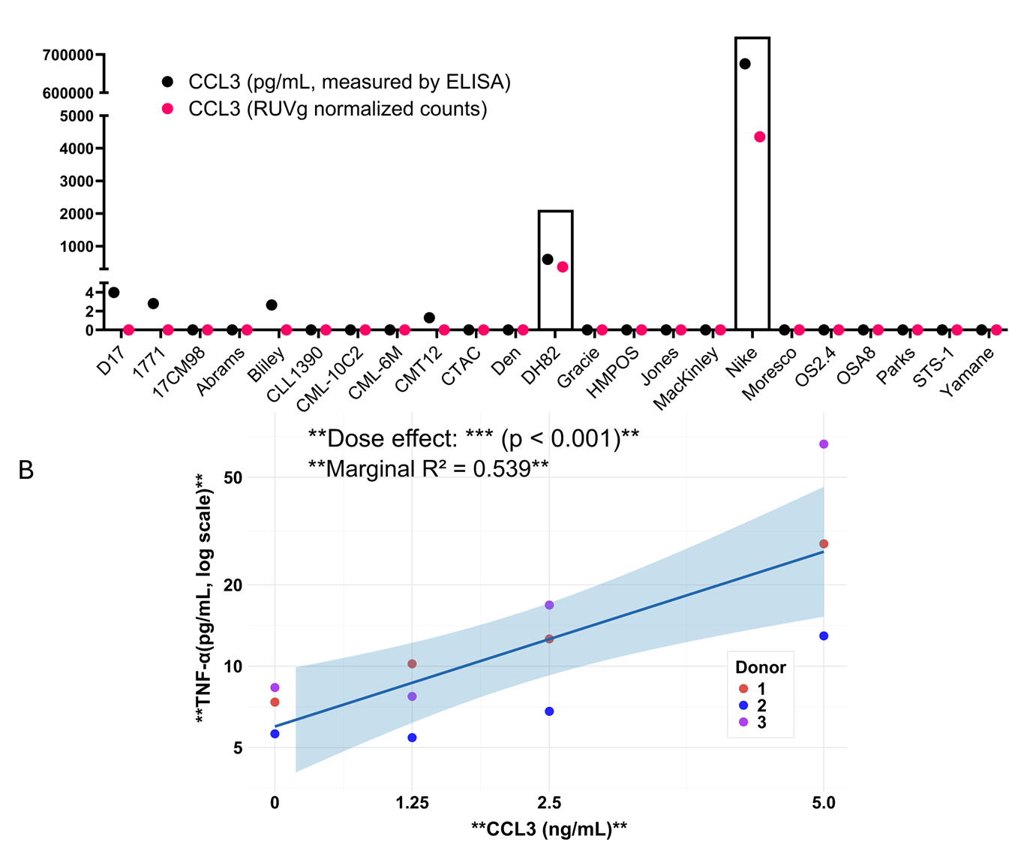

**Figure 7: *CCL3*‐induced TNF-α secretion by macrophages.** **(A)** CCL3 protein (black) and mRNA (magenta) levels in tumor-conditioned media from multiple cell lines. DH82 and Nike exhibit the highest transcript and secreted protein, whereas some lines show low protein levels despite undetectable mRNA. **(B)** Dose-dependent TNF-α secretion by primary macrophages in response to recombinant CCL3 (0–5 ng/mL). Linear mixed-effects modeling with donor as random effect revealed a significant dose effect *(p* < 0.001, marginal R² = 0.539), (n = 3 donors, 4 doses each).

**DISCUSSION**

This study tested two main hypotheses: first, that canine tumor cell lines differ in their ability to polarize macrophages independent of tumor type, and second, that the most potent polarizers have relevant gene expression profiles. We undertook this work because the TME is a major barrier to therapy and shows significant variability even within tumor types. TME-based biomarkers could therefore help stratify patients for immunotherapies. Here, we assessed the ability of cancer cell lines to stimulate immunomodulatory cytokines in primary macrophages as a simplified proxy for in vivo cancer cell-macrophage crosstalk and correlated these responses with cancer cell line transcriptomes.

We focused on macrophage-secreted cytokines as markers of an “active” TME rather than strict M1/M2 indicators. VEGF, TNF-α, IL-10, TGF-β, IL-8, CCL2, and KC-like showed significant variability between cell lines and are major players in the TME [29–31]. VEGF drives tumor angiogenesis and tumor cell survival, TGF-β promotes EMT, matrix remodeling, and immune cell exclusion, and CCL2 recruits immunosuppressive monocytes, myeloid-derived suppressor cells, and T-regulatory cells [31–33]. IL-8 and KC-like were moderately correlated and together recruit immunosuppressive myeloid subsets [29, 34]. IL-10 and TNF-α were strongly correlated, consistent with feedback balancing pro- and anti-inflammatory signaling [35]. These cytokine patterns help illustrate the complexity of how tumors maintain their TME. While we concentrated on TCM that drove high secretion, several lines actively repressed cytokines relative to unstimulated (M0) macrophages. This is most notable with VEGF and CCL2, and warrants further investigation. DEG and GSEA analysis revealed cytokine-specific enrichment patterns, with CCL2/VEGF linked with EMT and immune suppression, TNF-α with matrix remodeling, and IL-8 with MEK signaling. Several cytokines also shared upregulation of macrophage activation and regulation genes. Further work is needed to define mechanistic links between these cytokines and genomic patterns.

To examine the mechanistic link in one example case, we identified *MVB12A* as a DEG strongly associated with VEGF secretion from polarized macrophages. Because MVB12A is critical for loading exosomal cargo, we performed an exosome-enrichment assay. Macrophages incubated with the purified exosome fraction secreted significantly more VEGF than those treated with whole or exosome-depleted TCM. This suggests an inhibitory factor in unfractionated TCM that may counteract exosome-driven VEGF stimulation by regulating exosome uptake, fusion, or cargo release. The similar VEGF levels in unfractionated and exosome-depleted TCM may indicate soluble factors in the latter that independently stimulate VEGF.

We preliminarily explored how exosomes control VEGF release from macrophages. Possible mechanisms include direct VEGF carriage within exosomes, delivery of upstream regulators such as microRNA-21 that induce VEGF transcription, or broader reprogramming of macrophages toward an M2-like state [36, 37]. Lysis of the exosome fraction yielded significantly higher VEGF concentrations, most consistent with direct carriage. However, co-isolation of VEGF bound to contaminating proteins cannot be excluded. These findings warrant further study with larger cohorts and more rigorous isolation methods to clarify the contributions of tumor-derived exosomal versus soluble VEGF-stimulating factors.

We showed that seven of eight *MVB12A*-expressing cell lines stimulated VEGF release as expected. The exception was the HSA line CIN, which expressed high *MVB12A* but stimulated low VEGF. All *MVB12A*-high lines, including CIN, showed VEGF enrichment in exosomes compared to free VEGF, suggesting that CIN-derived exosomes may interact differently with macrophages. Another HSA line, SB, was also a low VEGF stimulator with low *MVB12A*, possibly reflecting a tumor type–specific adaptation. Despite high VEGF secretion, canine HSA cells are insensitive to VEGF-driven proliferation, so they may gain little benefit from macrophage-derived VEGF [38]. Similarly, human angiosarcoma, a comparable malignancy, harbors mutations causing ligand-independent VEGF receptor signaling, which may reduce reliance on secreted VEGF [39].

Although our efforts largely focused on tumor type–agnostic findings, we identified *CCL3* upregulation correlated with TNF-α secretion from macrophages only in HS cell lines. HS is a rare malignancy with poor prognosis in both humans and dogs, and no accepted standard-of-care treatment [40, 41]. The two HS lines with upregulated *CCL3* stimulated significantly higher TNF-α secretion, and recombinant *CCL3* showed a dose-dependent relationship with TNF-α in vitro. *CCL3* knockdown reduced TNF-α in macrophages from two of three donors, but the variable donor response suggests more complex regulation *in vivo.* The mechanism by which CCL3 drives TNF-α was not determined. One possibility is direct binding to CCR1/CCR5 on macrophages, activating mitogen-activated protein kinase (MAPK) or NF-κB signaling and TNF-α transcription [42]. Another is induction of an intermediary cytokine that in turn stimulates TNF-α. A recent study in mice showed that boosting CCL3 at tumor sites promoted dendritic cell recruitment, T-cell activation, and improved survival with checkpoint inhibitors [28].While chronic TNF-α can promote immune exhaustion, regulated CCL3 appears to support immune activation rather than suppression [28, 43]. Further work is needed to define how the CCL3–TNF-α axis contributes to these effects and whether it could be targeted for new HS therapies.

The main limitation of this study is that the in vitro system of TCM and monocyte-derived macrophages does not capture the full complexity of the TME in vivo. Another limitation is that the multiplex bead-based assay and individual ELISAs had different sensitivities and dynamic ranges, so direct comparison of absolute analyte values is not recommended. We examined only the relationship between cell line transcriptomes and macrophage secretory products, without establishing direct links between proteins secreted in TCM and those released by macrophages. Protein secretion may not match mRNA levels due to post-transcriptional regulation, as shown by CCL3 protein secretion despite undetectable transcripts in some lines. Future studies integrating proteomic TCM analysis with macrophage phenotyping would help define mechanistic connections between tumor-secreted factors and macrophage polarization. Finally, the sample size of 25 cell lines and a small number of donors enabled proof-of-concept validation but was insufficient to assess whether donor disease influenced macrophage responses. Expanded studies are needed to fully capture inter-donor variability and patient diversity.

**CONCLUSIONS**

In summary, single-cell RNA-seq studies have identified multiple TAM states in human tumors [3, 4]. Our approach builds on this by tracking functional secretory outputs following TCM exposure, providing phenotypic measurements of tumor cell signals. Measuring active cytokine release from macrophages complements static gene expression analyses. Although this study used canine models, its relevance to human cancer immunology is supported by conserved cross-species immune pathways and prior translational successes [16, 44, 45]. Combining secretory profiling with transcriptomic subtyping could aid patient stratification by integrating molecular and functional aspects of TAM heterogeneity. Including biomarkers such as MVB12A or CCL3 in prospective trials could identify patients needing therapies targeting the VEGF pathway, exosome biogenesis, or cytokine modulation. Further testing in murine and canine models, and ultimately in human systems, will determine whether this platform improves stratification for TME-centric therapies.

**References**

1. de Visser KE, Joyce JA (2023) The evolving tumor microenvironment: From cancer initiation to metastatic outgrowth. Cancer Cell 41:374–403. https://doi.org/10.1016/J.CCELL.2023.02.016

2. Xiao Y, Yu D (2020) Tumor microenvironment as a therapeutic target in cancer. Pharmacol Ther 221:107753. https://doi.org/10.1016/J.PHARMTHERA.2020.107753

3. Nieto P, Elosua-Bayes M, Trincado JL, Marchese D, Massoni-Badosa R, Salvany M, Henriques A, Nieto J, Aguilar-Fernández S, Mereu E, Moutinho C, Ruiz S, Lorden P, Chin VT, Kaczorowski D, Chan CL, Gallagher R, Chou A, Planas-Rigol E, Rubio-Perez C, Gut I, Piulats JM, Seoane J, Powell JE, Batlle E, Heyn H (2021) A single-cell tumor immune atlas for precision oncology. Genome Res 31:1913–1926. https://doi.org/10.1101/GR.273300.120

4. Cheng S, Li Z, Gao R, Xing B, Gao Y, Yang Y, Qin S, Zhang L, Ouyang H, Du P, Jiang L, Zhang B, Yang Y, Wang X, Ren X, Bei JX, Hu X, Bu Z, Ji J, Zhang Z (2021) A pan-cancer single-cell transcriptional atlas of tumor infiltrating myeloid cells. Cell 184:792-809.e23. https://doi.org/10.1016/J.CELL.2021.01.010

5. Emens LA, Romero PJ, Anderson AC, Bruno TC, Capitini CM, Collyar D, Gulley JL, Hwu P, Posey AD, Silk AW, Wargo JA (2024) Challenges and opportunities in cancer immunotherapy: a Society for Immunotherapy of Cancer (SITC) strategic vision. J Immunother Cancer 12:e009063. https://doi.org/10.1136/JITC-2024-009063

6. Huang AC, Zappasodi R (2022) A decade of checkpoint blockade immunotherapy in melanoma: understanding the molecular basis for immune sensitivity and resistance. Nat Immunol 23:660–670. https://doi.org/10.1038/S41590-022-01141-1

7. Stanley R, Flanagan S, Reilly DO, Kearney E, Naidoo J, Dowling CM (2023) Immunotherapy through the Lens of Non-Small Cell Lung Cancer. Cancers (Basel) 15:2996. https://doi.org/10.3390/CANCERS15112996

8. Lin Z, Huang L, Li SL, Gu J, Cui X, Zhou Y (2021) PTEN loss correlates with T cell exclusion across human cancers. BMC Cancer 21:. https://doi.org/10.1186/S12885-021-08114-X

9. Zhang C, Liu J, Xu D, Zhang T, Hu W, Feng Z (2020) Gain-of-function mutant p53 in cancer progression and therapy. J Mol Cell Biol 12:674–687. https://doi.org/10.1093/JMCB/MJAA040

10. Ringel AE, Drijvers JM, Baker GJ, Catozzi A, García-Cañaveras JC, Gassaway BM, Miller BC, Juneja VR, Nguyen TH, Joshi S, Yao CH, Yoon H, Sage PT, LaFleur MW, Trombley JD, Jacobson CA, Maliga Z, Gygi SP, Sorger PK, Rabinowitz JD, Sharpe AH, Haigis MC (2020) Obesity shapes metabolism in the tumor microenvironment to suppress anti-tumor immunity. Cell 183:1848. https://doi.org/10.1016/J.CELL.2020.11.009

11. Zhou Z, Wei JH, Jiang W (2022) Characterization of aging tumor microenvironment with drawing implications in predicting the prognosis and immunotherapy response in low-grade gliomas. Scientific Reports 2022 12:1 12:1–16. https://doi.org/10.1038/s41598-022-09549-3

12. Chen X, Ma Z, Yi Z, Wu E, Shang Z, Tuo B, Li T, Liu X (2024) The effects of metabolism on the immune microenvironment in colorectal cancer. Cell Death Discov 10:. https://doi.org/10.1038/S41420-024-01865-Z

13. Huang J, Zhang J, Guo Z, Li C, Tan Z, Wang J, Yang J, Xue L (2021) Easy or Not—The Advances of EZH2 in Regulating T Cell Development, Differentiation, and Activation in Antitumor Immunity. Front Immunol 12:741302. https://doi.org/10.3389/FIMMU.2021.741302

14. Kzhyshkowska J, Shen J, Larionova I (2024) Targeting of TAMs: can we be more clever than cancer cells? Cellular & Molecular Immunology 2024 21:12 21:1376–1409. https://doi.org/10.1038/s41423-024-01232-z

15. Brady R V, Thamm DH (2023) Tumor-associated macrophages: Prognostic and therapeutic targets for cancer in humans and dogs. https://doi.org/10.3389/fimmu.2023.1176807

16. Klosowski M, Haines L, Alfino L, McMellen A, Leibowitz M, Regan D (2023) Naturally occurring canine sarcomas: Bridging the gap from mouse models to human patients through cross-disciplinary research partnerships. Front Oncol 13:. https://doi.org/10.3389/FONC.2023.1130215

17. Leblanc AK, Mazcko CN, Khanna C (2016) Defining the Value of a Comparative Approach to Cancer Drug Development. Clin Cancer Res 22:2133–2138. https://doi.org/10.1158/1078-0432.CCR-15-2347

18. Williams HL, Frei AL, Koessler T, Berger MD, Dawson H, Michielin O, Zlobec I (2024) The current landscape of spatial biomarkers for prediction of response to immune checkpoint inhibition. NPJ Precis Oncol 8:1–18. https://doi.org/10.1038/S41698-024-00671-1;SUBJMETA=1059,1857,2325,631,67;KWRD=CANCER+IMMUNOTHERAPY,TUMOUR+BIOMARKERS

19. O’Donoghue LE, Rivest JP, Duval DL (2011) Polymerase chain reaction-based species verification and microsatellite analysis for canine cell line validation. J Vet Diagn Invest 23:780–785. https://doi.org/10.1177/1040638711408064

20. Volume 16: How to Detect and Handle Outliers

21. Das S, Idate R, Cronise KE, Gustafson DL, Duval DL (2019) Identifying Candidate Druggable Targets in Canine Cancer Cell Lines Using Whole-Exome Sequencing. Mol Cancer Ther 18:1460–1471. https://doi.org/10.1158/1535-7163.MCT-18-1346

22. Zeng Y, Du X, Jiang W, Qiu Y (2022) Measurement of VEGF Content in Exosomes and Subsequent Tumor Tubulogenesis and In Vivo Angiogenesis Functional Assays. Methods in Molecular Biology 2475:79–96. https://doi.org/10.1007/978-1-0716-2217-9_5,

23. Team RC (2023) R Core Team 2023 R: A language and environment for statistical computing. R foundation for statistical computing. https://www.R-project.org/. R Foundation for Statistical Computing

24. Farrell KB, Das S, Nordeen SK, Lambert JR, Thamm DH (2024) VDX-111 targets proliferative pathways in canine cancer cell lines. PLoS One 19:e0303470. https://doi.org/10.1371/JOURNAL.PONE.0303470

25. Tsunematsu T, Yamauchi E, Shibata H, Maki M, Ohta T, Konishi H (2010) Distinct functions of human MVB12A and MVB12B in the ESCRT-I dependent on their posttranslational modifications. Biochem Biophys Res Commun 399:232–237. https://doi.org/10.1016/J.BBRC.2010.07.060

26. Zappa F, Wilson C, Tullio G Di, Santoro M, Pucci P, Monti M, D’Amico D, Pisonero‐Vaquero S, Cegli R De, Romano A, Saleem MA, Polishchuk E, Failli M, Giaquinto L, Matteis MA De (2019) The TRAPP complex mediates secretion arrest induced by stress granule assembly. EMBO J 38:e101704. https://doi.org/10.15252/EMBJ.2019101704

27. Seal RL, Braschi B, Gray K, Jones TEM, Tweedie S, Haim-Vilmovsky L, Bruford EA (2023) Genenames.org: the HGNC resources in 2023. Nucleic Acids Res 51:D1003–D1009. https://doi.org/10.1093/NAR/GKAC888

28. Kang TG, Park HJ, Moon J, Lee JH, Ha SJ (2021) Enriching CCL3 in the Tumor Microenvironment Facilitates T cell Responses and Improves the Efficacy of Anti-PD-1 Therapy. Immune Netw 21:e23. https://doi.org/10.4110/IN.2021.21.E23

29. Korbecki J, Bosiacki M, Barczak K, Łagocka R, Brodowska A, Chlubek D, Baranowska-Bosiacka I (2023) Involvement in Tumorigenesis and Clinical Significance of CXCL1 in Reproductive Cancers: Breast Cancer, Cervical Cancer, Endometrial Cancer, Ovarian Cancer and Prostate Cancer. Int J Mol Sci 24:7262. https://doi.org/10.3390/IJMS24087262

30. Kartikasari AER, Huertas CS, Mitchell A, Plebanski M (2021) Tumor-Induced Inflammatory Cytokines and the Emerging Diagnostic Devices for Cancer Detection and Prognosis. Front Oncol 11:692142. https://doi.org/10.3389/FONC.2021.692142/XML/NLM

31. Kadomoto S, Izumi K, Mizokami A (2021) Roles of CCL2-CCR2 Axis in the Tumor Microenvironment. Int J Mol Sci 22:8530. https://doi.org/10.3390/IJMS22168530

32. Wang X, Eichhorn PJA, Thiery JP (2023) TGF-β, EMT, and resistance to anti-cancer treatment. Semin Cancer Biol 97:1–11. https://doi.org/10.1016/J.SEMCANCER.2023.10.004

33. Patel SA, Nilsson MB, Le X, Cascone T, Jain RK, Heymach J V. (2023) Molecular Mechanisms and Future Implications of VEGF/VEGFR in Cancer Therapy. Clin Cancer Res 29:30. https://doi.org/10.1158/1078-0432.CCR-22-1366

34. Rizzo M, Varnier L, Pezzicoli G, Pirovano M, Cosmai L, Porta C (2022) IL-8 and its role as a potential biomarker of resistance to anti-angiogenic agents and immune checkpoint inhibitors in metastatic renal cell carcinoma. Front Oncol 12:990568. https://doi.org/10.3389/FONC.2022.990568/BIBTEX

35. Goswami B, Rajappa M, Mallika V, Kumar Shukla D, Kumar S (2009) TNF-α/IL-10 ratio and C-reactive protein as markers of the inflammatory response in CAD-prone North Indian patients with acute myocardial infarction. https://doi.org/10.1016/j.cca.2009.06.029

36. Saadh MJ, Jasim NY, Ahmed MH, Ballal S, Kumar A, Atteri S, Vashishth R, Rizaev J, Alhili A, Jawad MJ, Yazdi F, Salajegheh A, Akhavan-Sigari R (2025) Critical roles of miR-21 in promotions angiogenesis: friend or foe? Clinical and Experimental Medicine 2025 25:1 25:1–23. https://doi.org/10.1007/S10238-025-01600-7

37. Deng C, Huo M, Chu H, Zhuang X, Deng G, Li W, Wei H, Zeng L, He Y, Liu H, Li J, Zhang C, Chen H (2024) Exosome circATP8A1 induces macrophage M2 polarization by regulating the miR-1-3p/STAT6 axis to promote gastric cancer progression. Mol Cancer 23:1–19. https://doi.org/10.1186/S12943-024-01966-4/FIGURES/8

38. Adachi M, Hoshino Y, Izumi Y, Sakai H, Takagi S (2016) Effects of inhibitors of vascular endothelial growth factor receptor 2 and downstream pathways of receptor tyrosine kinases involving phosphatidylinositol 3-kinase/Akt/mammalian target of rapamycin or mitogen-activated protein kinase in canine hemangiosarcoma cell lines. Canadian Journal of Veterinary Research 80:209

39. Benton A, Liu B, Gartenhaus LE, Hanna JA (2024) Genomic landscape and preclinical models of angiosarcoma. Mol Oncol 19:965. https://doi.org/10.1002/1878-0261.13744

40. Hung YP, Qian X (2020) Histiocytic Sarcoma. Arch Pathol Lab Med 144:650–654. https://doi.org/10.5858/ARPA.2018-0349-RS

41. Moore PF (2023) Histiocytic Diseases. Vet Clin North Am Small Anim Pract 53:121–140. https://doi.org/10.1016/J.CVSM.2022.07.010

42. Shaheen ZR, Christmann BS, Stafford JD, Moran JM, Buller RML, Corbett JA (2019) CCR5 is a required signaling receptor for macrophage expression of inflammatory genes in response to viral double-stranded RNA. Am J Physiol Regul Integr Comp Physiol 316:R525–R534. https://doi.org/10.1152/AJPREGU.00019.2019,

43. Gane JM, Stockley RA, Sapey E (2016) TNF- α Autocrine Feedback Loops in Human Monocytes: The Pro- and Anti-Inflammatory Roles of the TNF- α Receptors Support the Concept of Selective TNFR1 Blockade in Vivo. J Immunol Res 2016:. https://doi.org/10.1155/2016/1079851,

44. Felsburg PJ (2002) Overview of immune system development in the dog: comparison with humans. http://dx.doi.org/101191/0960327102ht286oa 21:487–492. https://doi.org/10.1191/0960327102HT286OA

45. Gardner HL, Fenger JM, London CA Dogs as a Model for Cancer. 4: